**Part 1**

**POS task –**

1. Parameters:
   1. Number of epochs: 7
   2. Learning rate: 1e-4
   3. Batch size: 32
   4. Hidden layer size: 150
   5. Optimizer: Adam
   6. Dropout with 0.5 probability
2. Results:
   1. Train loss: 0.00346
   2. Train accuracy: 97.007%
   3. Validation loss: 0.00619
3. Validation accuracy: 94.375%
4. Graphs:

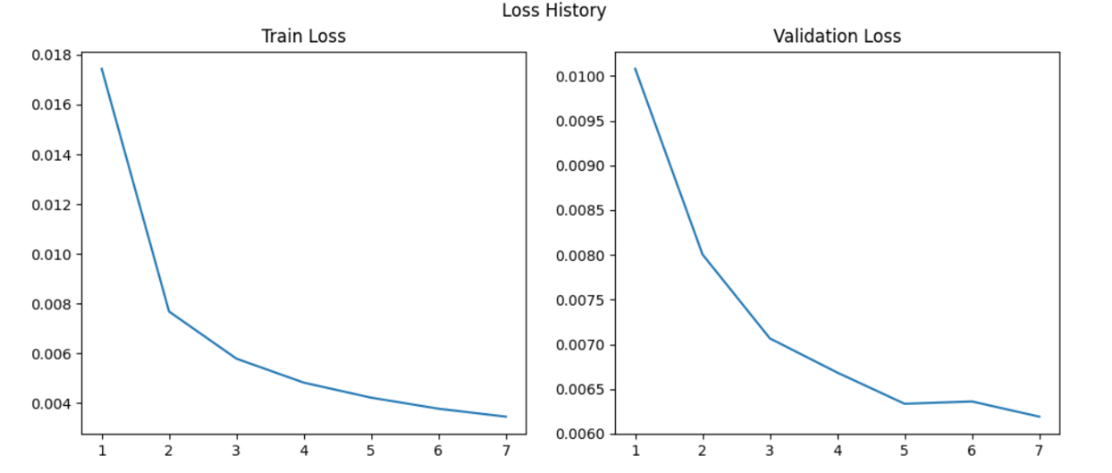

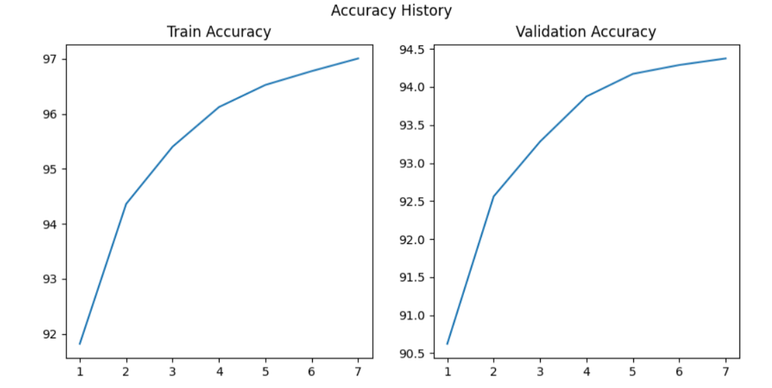

**NER task –**

1. Parameters:
   1. Number of epochs: 7
   2. Learning rate: 1e-4
   3. Batch size: 32
   4. Hidden layer size: 150
   5. Optimizer: Adam
   6. Dropout with 0.5 probability
2. Results:
   1. Train loss: 0.0174
   2. Train accuracy: 97.077%
   3. Validation loss: 0.0107
   4. Validation accuracy: 93.15%
3. Graphs: